File | Code | Comment
General | 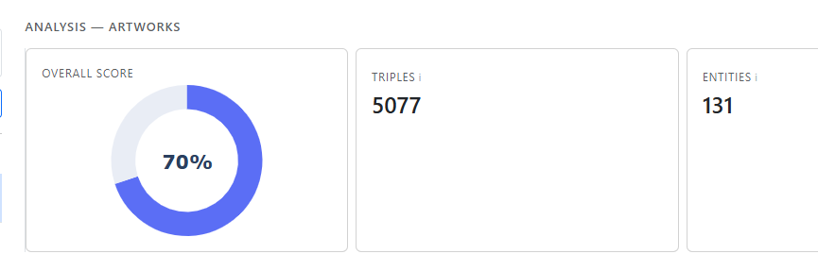  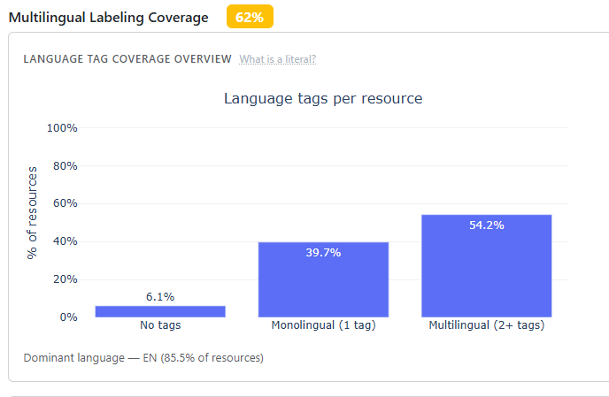  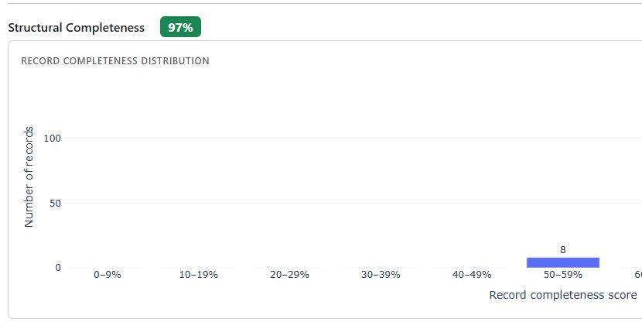 | I believe that in the different plots/tables we use different labels to name the same thing (entity, resource, record). If this were correct, and there is not a specific reason for calling them differently, I would choose one name and use it consistently everywhere.

File | Code | Comment
frontend/app.py | def sync_metric_selection(checklist_values):  from api_client import get_metrics, APIError  flat = []  for vals in (checklist_values or []):  flat.extend(vals or [])  try:  metrics = get_metrics()  metric_order = [m["metric_id"] for m in metrics]  flat.sort(key=lambda m: metric_order.index(m) if m in metric_order else 999)  except APIError:  pass # if API fails, return unsorted  return flat | I added some lines of code here to read again the metrics_config.json file so I can sort the selected metrics so later the results are sorted with the order on the sidebar, rather than with the order they were selected.
General |  | When I load this file, I can see 6 classes, when I evaluate it, if later I click in property coverage I see the 6 classes in the corresponding plots, the same with multilingual and foundational but I see only 4 in the structural completeness, the classes missing are license and organization.
frontend/callbacks/sources.py | def populate_metrics(_):  accordion = dbc.Accordion(  items,  start_collapsed=False,  always_open=True,  flush=True,  className="mb-1",  style={"fontSize": "0.875rem"},  ) | I have added this line, so the sidebars remain open if i dont close them , rather than self-close when open one

File | Code | Comment
frontend/layout/sidebar.py | def build_add_source_modal() -> dbc.Modal:  # RDF File fields  html.Div(  id="source-fields-rdf",  children=[  dbc.Label("File path", html_for="input-file-path"),  dcc.Upload(  id="upload-rdf-file",  children=html.Div([  "Drag and Drop or ",  html.A("Select File", style={"color": "#6c8ebf", "cursor": "pointer"}),  ]),  style={  "borderWidth": "1px",  "borderStyle": "dashed",  "borderColor": "#adb5bd",  "borderRadius": "6px",  "textAlign": "center",  "padding": "20px",  "cursor": "pointer",  "backgroundColor": "#f8f9fa",  "marginBottom": "8px",  },  ),  html.Small("or enter path manually", className="text-muted my-1 d-block"),  dbc.Input(  id="input-file-path",  placeholder="e.g. C:\\Users\\victo\\data\\file.ttl",  className="mb-2",  ),  html.Div(id="upload-filename-display", className="text-muted mb-2",  style={"fontSize": "0.8rem"}),  dbc.Label("Format", html_for="input-file-format"),  dbc.Label("Format", html_for="input-file-format"),  dbc.Select(  id="input-file-format",  options=[  {"label": "Turtle (.ttl)", "value": "turtle"},  {"label": "RDF/XML (.rdf)", "value": "xml"},  {"label": "N-Triples (.nt)", "value": "nt"},  {"label": "N3 (.n3)", "value": "n3"},  ],  value="turtle",  ),  ],  ), | I change it to be able to drag and drop files when loading data, at least for me it make it easier to test things from the interface.  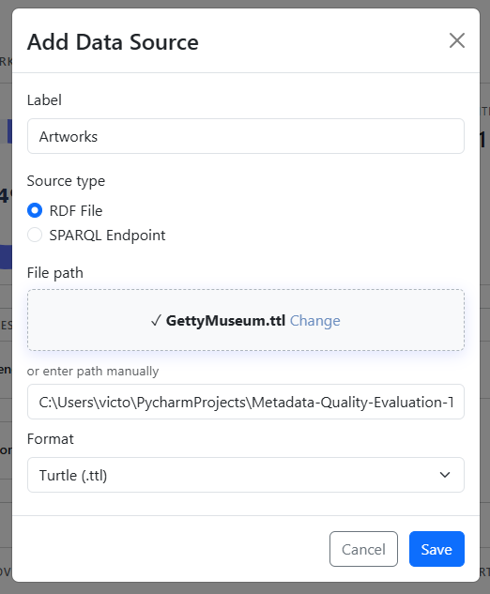
General | 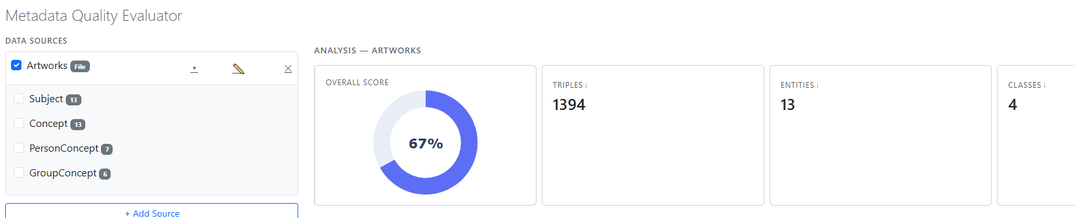  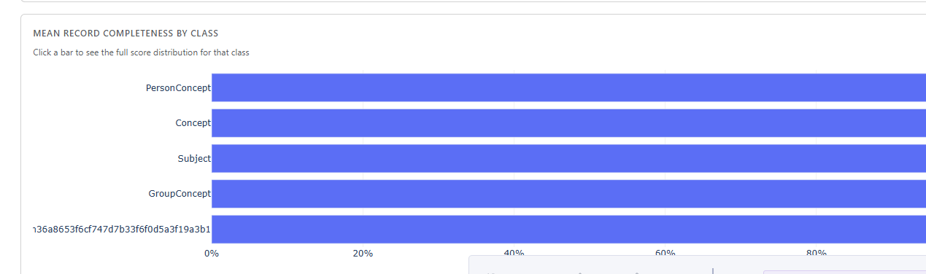 | I manage to get some data from Getty museum . The important thing is that when I run the analysis, I see 4 classes on top, but the graph “MEAN RECORD COMPLETENESS BY CLASS” shows a 5 one.

File | Code | Comment
General | 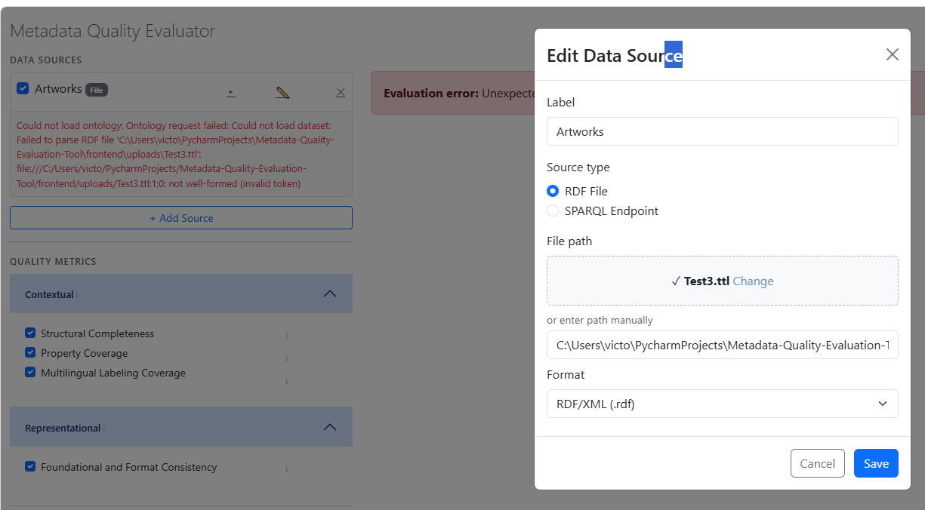  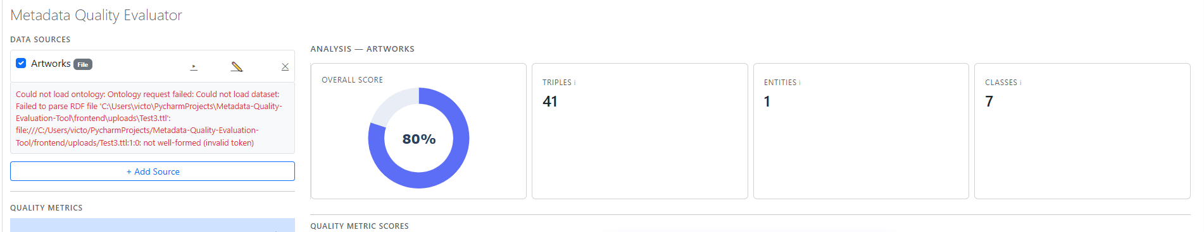 | When I add a RDF file, if I don’t choose the correct format, when I try to run the evaluation I will get an error as expected (first image).  If later I correct the Format of the file, the run evaluation will run as expected, but the error is still there, and actually I don’t see the classes of the data(second image)

General suggestion | 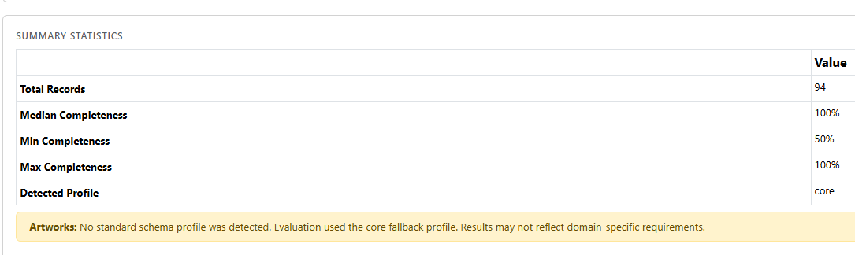 | Should we include somewhere the definition of the profile used to evaluate the Structural Completeness? After a while I found the folder with the profiles and the files with the shacl definitions, and I understood how it works, maybe we could add a button or similar somewhere, so when you clicked you see something like the image below  